**Okta Registration**

* Connect with web browser to Okta <https://johndeere.okta.com/>
* Type in your JDNET user ID in “Username” – tab – and your RACF/JDNET password in “Password”. Click on Sign In.

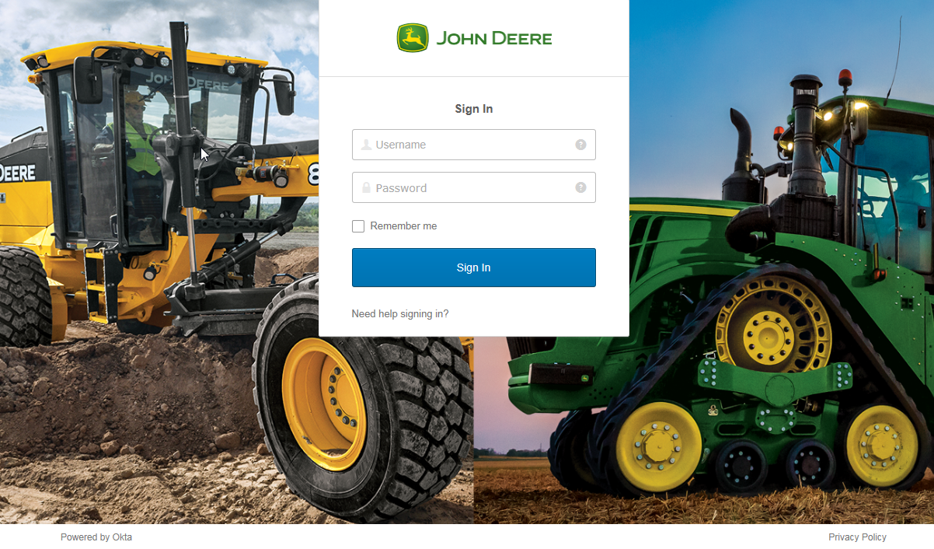

* You will be presented with screen showing five options for 2nd factor authentication.

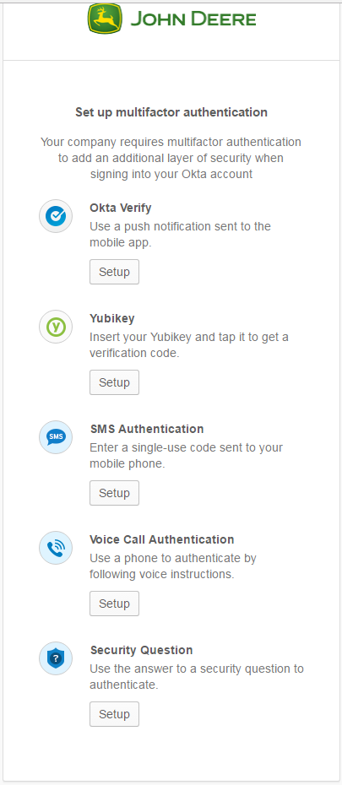

**Okta Verify** – requires a “smart” phone. You will need to download the Okta Verify application from their device’s apps store before registering for this method of authentication. A signal is sent to your phone (which must be on and accessible) that will require you to tap the Okta app to verify that the phone is in your possession – no other action is required.

**How to set up Okta Verify**

* Click on Set Up
* Choose the device Type

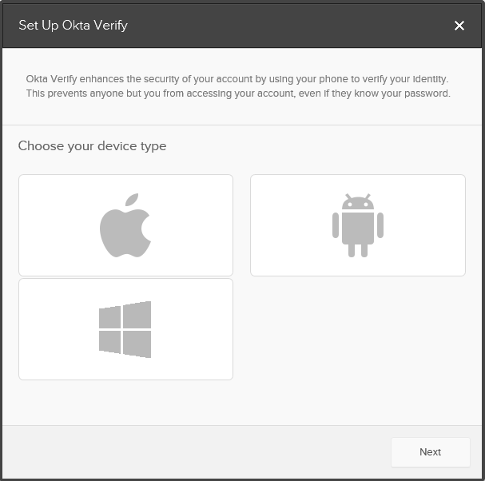

* Download Okta verify application from the device app store and click on next.

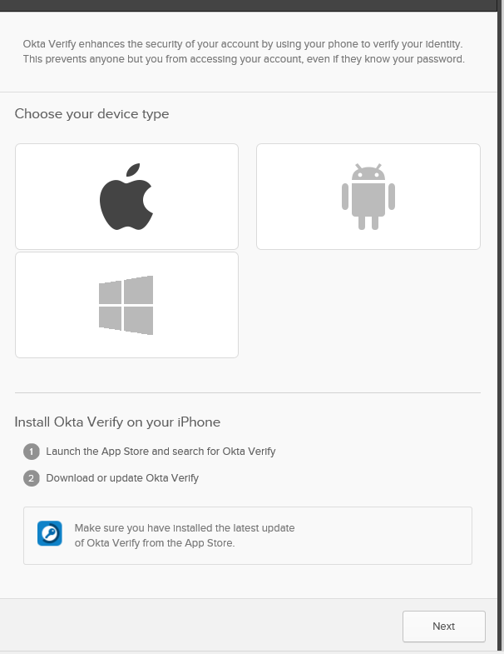

* Open the downloaded Okta Verify app on your phone , and tap on **Add** **Account**, and click on Next
* As soon as you click on **Add Account**, a camera will open up
* Scan the QR code on your computer screen using the opened phone camera.
* Wait until your device enrolls. It takes a while to enroll your device.
* When their device is successfully enrolled, you will be able to see a message that the device is successfully enrolled with a green tick mark
* You are now set up with Okta Verify MFA

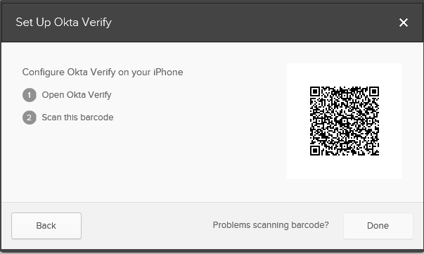

**SMS Authentication** – sends a six digit text message to your phone that you will need to type in on the Okta login screen to authenticate.

1. Click on “Set up SMS Authentication”

2. Enter your mobile number without country code

3. Click on “Send code”

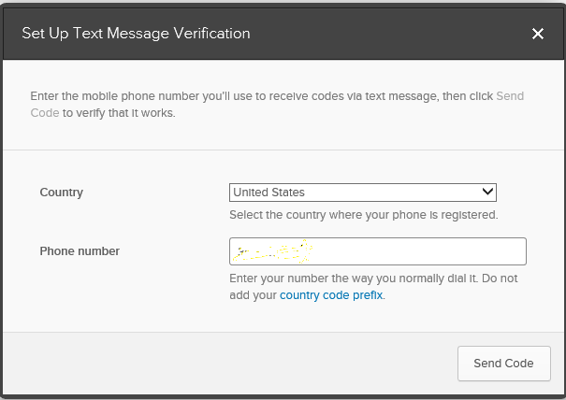

4. As soon as you click on “send code”, you will be sent a 6 digit code as a text message (The Verification code is “XXXXXX“) to your SMS device.

5. Open the text message and enter the 6 digit code in the next screen and hit on verify. Be sure to delete the text message after authentication – it is only good for a single use!

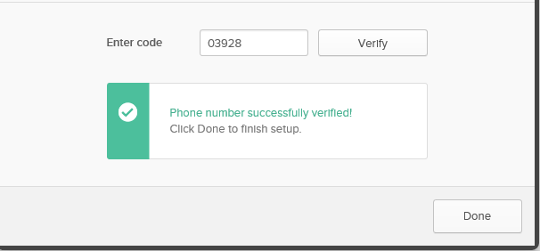

6. Now your mobile number is registered with SMS Authentication for MFA.

**Voice Call Authentication** – sends a voice message to a designated phone number (can either be a land line or a mobile phone)

1. Click on set up Voice Call Authentication

2. Enter your phone number without country code, and enter if you have any extension

3. Click on the “Call” button

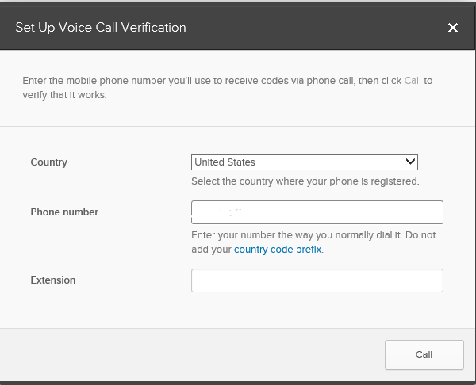

4. As soon as you click on “call”, your phone will get a call from Okta.

5. Answer the call and listen to the 5 digit code.

6. Enter the 5 digit code from the call and hit on “verify”

7. Now your phone number is registered with Voice Call Authentication for MFA.

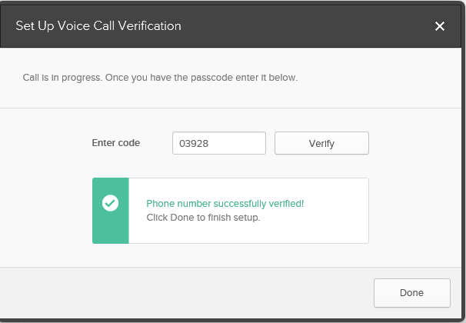

**YubiKey –** Please request a YubiKey through [Deere Hardware Request URL](https://hardwarerequest.deere.com). Once received, this option can be selected.

1. Insert your YubiKey into an available USB port on your computer
2. Tap the YubiKey button

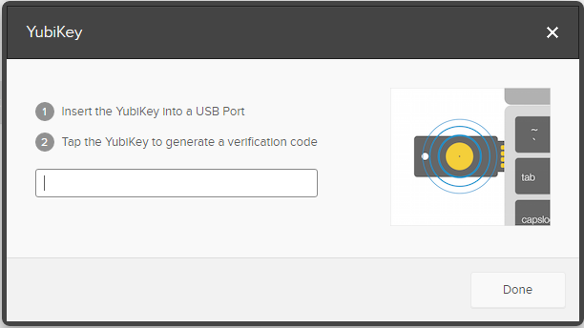

1. Done

**Security Question** –select and submit a typed response to one of several predefined questions in order to authenticate. **NOTE: This option will no longer be available for MFA effective July 5, 2017 and cannot be used for VDI/Citrix access.**

1. Select a comfortable question from the drop down
2. Type the response and hit on save
3. Remember the response they set up.

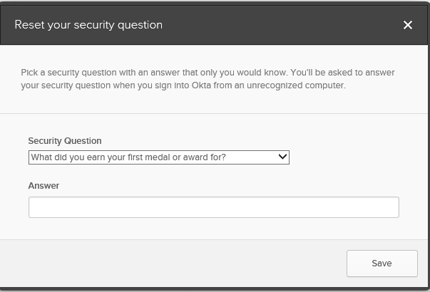

**We strongly recommend everyone to set up at least 2 methods of MFA.** This will allow you one method for normal MFA access, and a “backup” method in case your normal method is not available (forgotten response, phone lost/reimaged/broken/not usable, YubiKey lost/broken).

After setting up MFA options, click on “finish”.